Konecranes appoints new Global Sales Manager for Liftace products

Mr. Johan Bjerstedt has been appointed Global Sales Manager for Konecranes Liftace product family to grow sales and lead the way to further success for this important product group.
Since Konecranes acquisition of Terex MHPS in early 2017, the Lift Trucks business unit has two product families; Konecranes SMV, a range of premium products that are smarter where it matters, and Konecranes Liftace, a range of value based, robust lift trucks that are highly appreciated for the ease of maintenance.
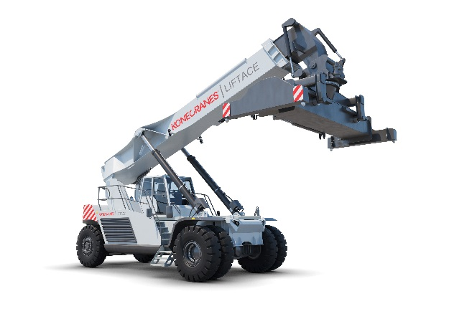
Johan Bjerstedt is currently working with sales of Konecranes SMV products: “The Konecranes Liftace product family with its long history is a great asset and widens Konecranes lift trucks offering. I look humbly on the task to carry on this legacy under the Konecranes name, and I’m excited for the future and what we can achieve.”

Further information:
Andreas Falk, Global Sales & Marketing Director, Konecranes Lift Trucks
Email: andreas.falk@konecranes.com or phone: +46 733 357 070

Erica Månsson, Marketing Coordinator, Konecranes Lift Trucks
Email: erica.mansson@konecranes.com or phone: +46 706 100 905

This press release together with a photo is available at our website kclifttrucks.com

Konecranes is a world-leading group of Lifting Businesses™, serving a broad range of customers, including manufacturing and process industries, shipyards, ports and terminals. Konecranes provides productivity enhancing lifting solutions as well as services for lifting equipment of all makes. In 2016, Group (comparable combined company) sales totaled EUR 3,278 million. The Group has 17,000 employees at 600 locations in 50 countries. Konecranes class A shares are listed on the Nasdaq Helsinki (symbol: KCR).

